Changing your club on the CGA system

**Step 1:** Go to the CGA website: <https://www.cgaonline.co.za/>

**Step 2:** You will likely already be registered on the CGA system, so you can click “Login” if you have previously been registered, using your cellphone number. If not, you can create a new CGA account by clicking on either “New Registration/Licence Renewal” or

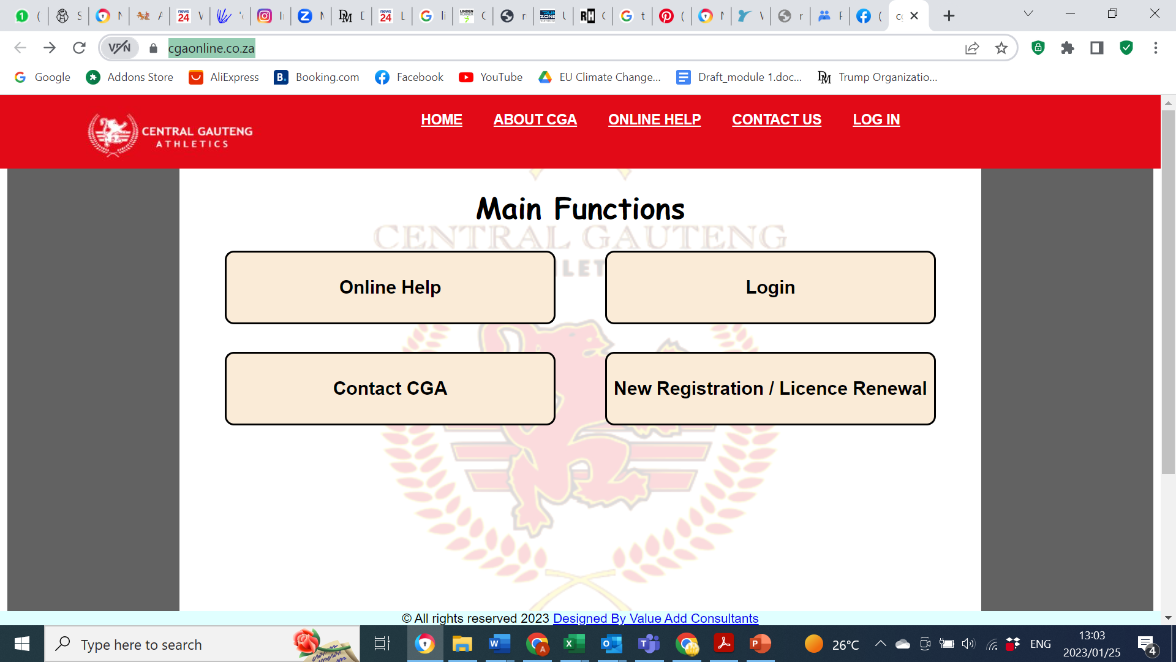

**Step 3:** Click on “Transfers”

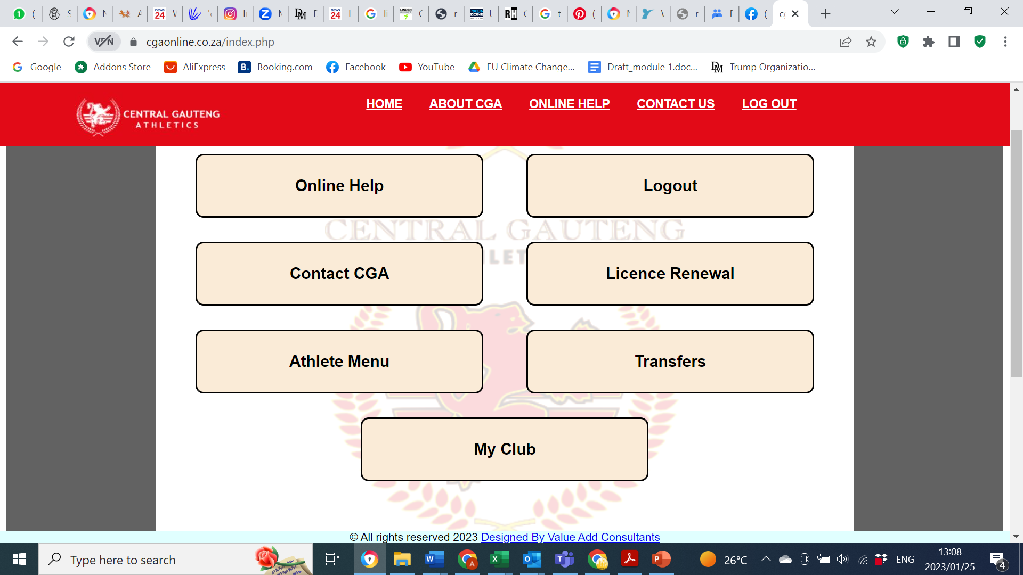

**Step 4:** Select your new club as “Ekhaya AC”

**Step 5:** Click on “I have received Transfer Letter From Club”; type in a brief motivation for the transfer, and check the box that the information in the form is correct, then click “Submit”

